SALES FORECASTING MODEL FOR INVENTORY AND BUDGET PLANNING: RESEARCH REPORT

CHAPTER THREE: RESEARCH METHODOLOGY

3.1 Introduction
The research methodology for the "Sales Forecasting Model for Inventory and Budget Planning" system follows a structured data-driven approach. The study aims to move beyond reactive inventory management by employing predictive analytics. We focus on two primary machine learning techniques: Linear Regression for trend analysis and SARIMA (Seasonal Autoregressive Integrated Moving Average) for capturing complex seasonal patterns. The methodology ensures that forecasts directly inform inventory replenishment and budget allocation.

3.2 Analysis of the Existing System
Traditional inventory systems often rely on manual entry, simple spreadsheets, or "gut feeling" to determine stock levels.

Limitations of the Existing System
• Lack of Foresight: Decisions are based on past stockouts rather than future demand, leading to lost sales or overstocking.
• Manual Error: Spreadsheets are prone to human error and difficult to scale as product catalogs grow.
• Static Budgeting: Budgets are often fixed and do not adjust to real-time sales performance or seasonal spikes.
• Data Silos: Inventory, sales, and budget data are often disconnected, preventing a holistic view of financial health.

3.3 Overview of the Proposed System
The proposed system is an integrated Sales Forecasting Dashboard that uses time-series analysis to predict demand and automate inventory/budget tracking.

3.3.1 Objectives of the Proposed System
• To provide proactive demand forecasting using multiple ML models.
• To automate inventory decrementing upon successful sale recording.
• To monitor budget utilization in real-time against sales revenue and cost targets.
• To offer a visual interface for comparing model performance (Linear vs. SARIMA).

3.4 System Architecture and Design
The system follows a modular architecture consisting of data handling, feature extraction, model inference, and result presentation.

3.4.1 Architectural Design of the System
The following diagram illustrates the flow from the user interface through the FastAPI backend to the machine learning models and database.
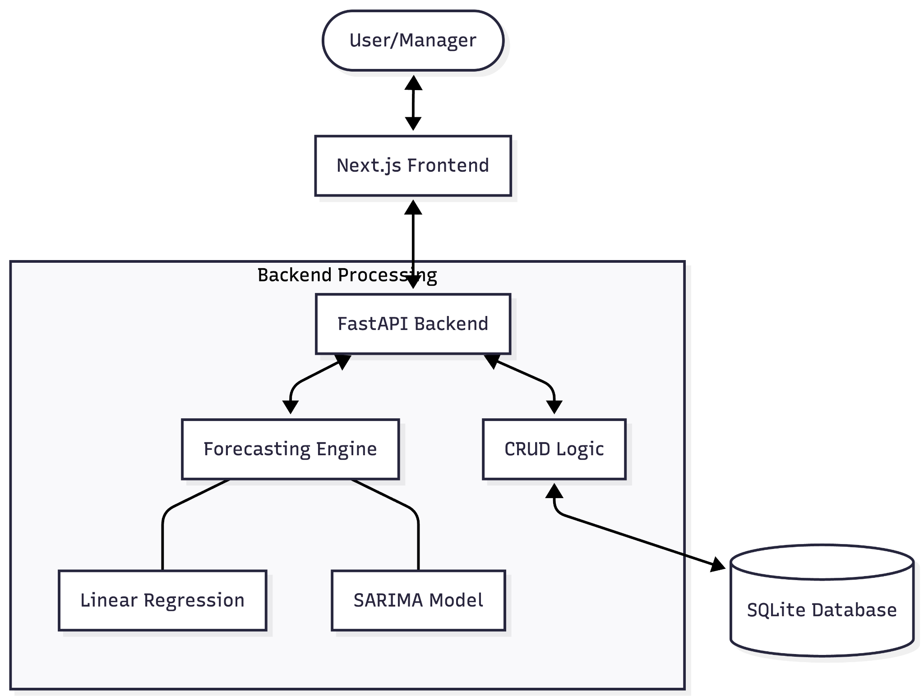
Figure 3.1: System Architecture Diagram

3.4.2 Use Case Diagram
The system supports two primary roles: the Sales Manager and the Inventory Planner.
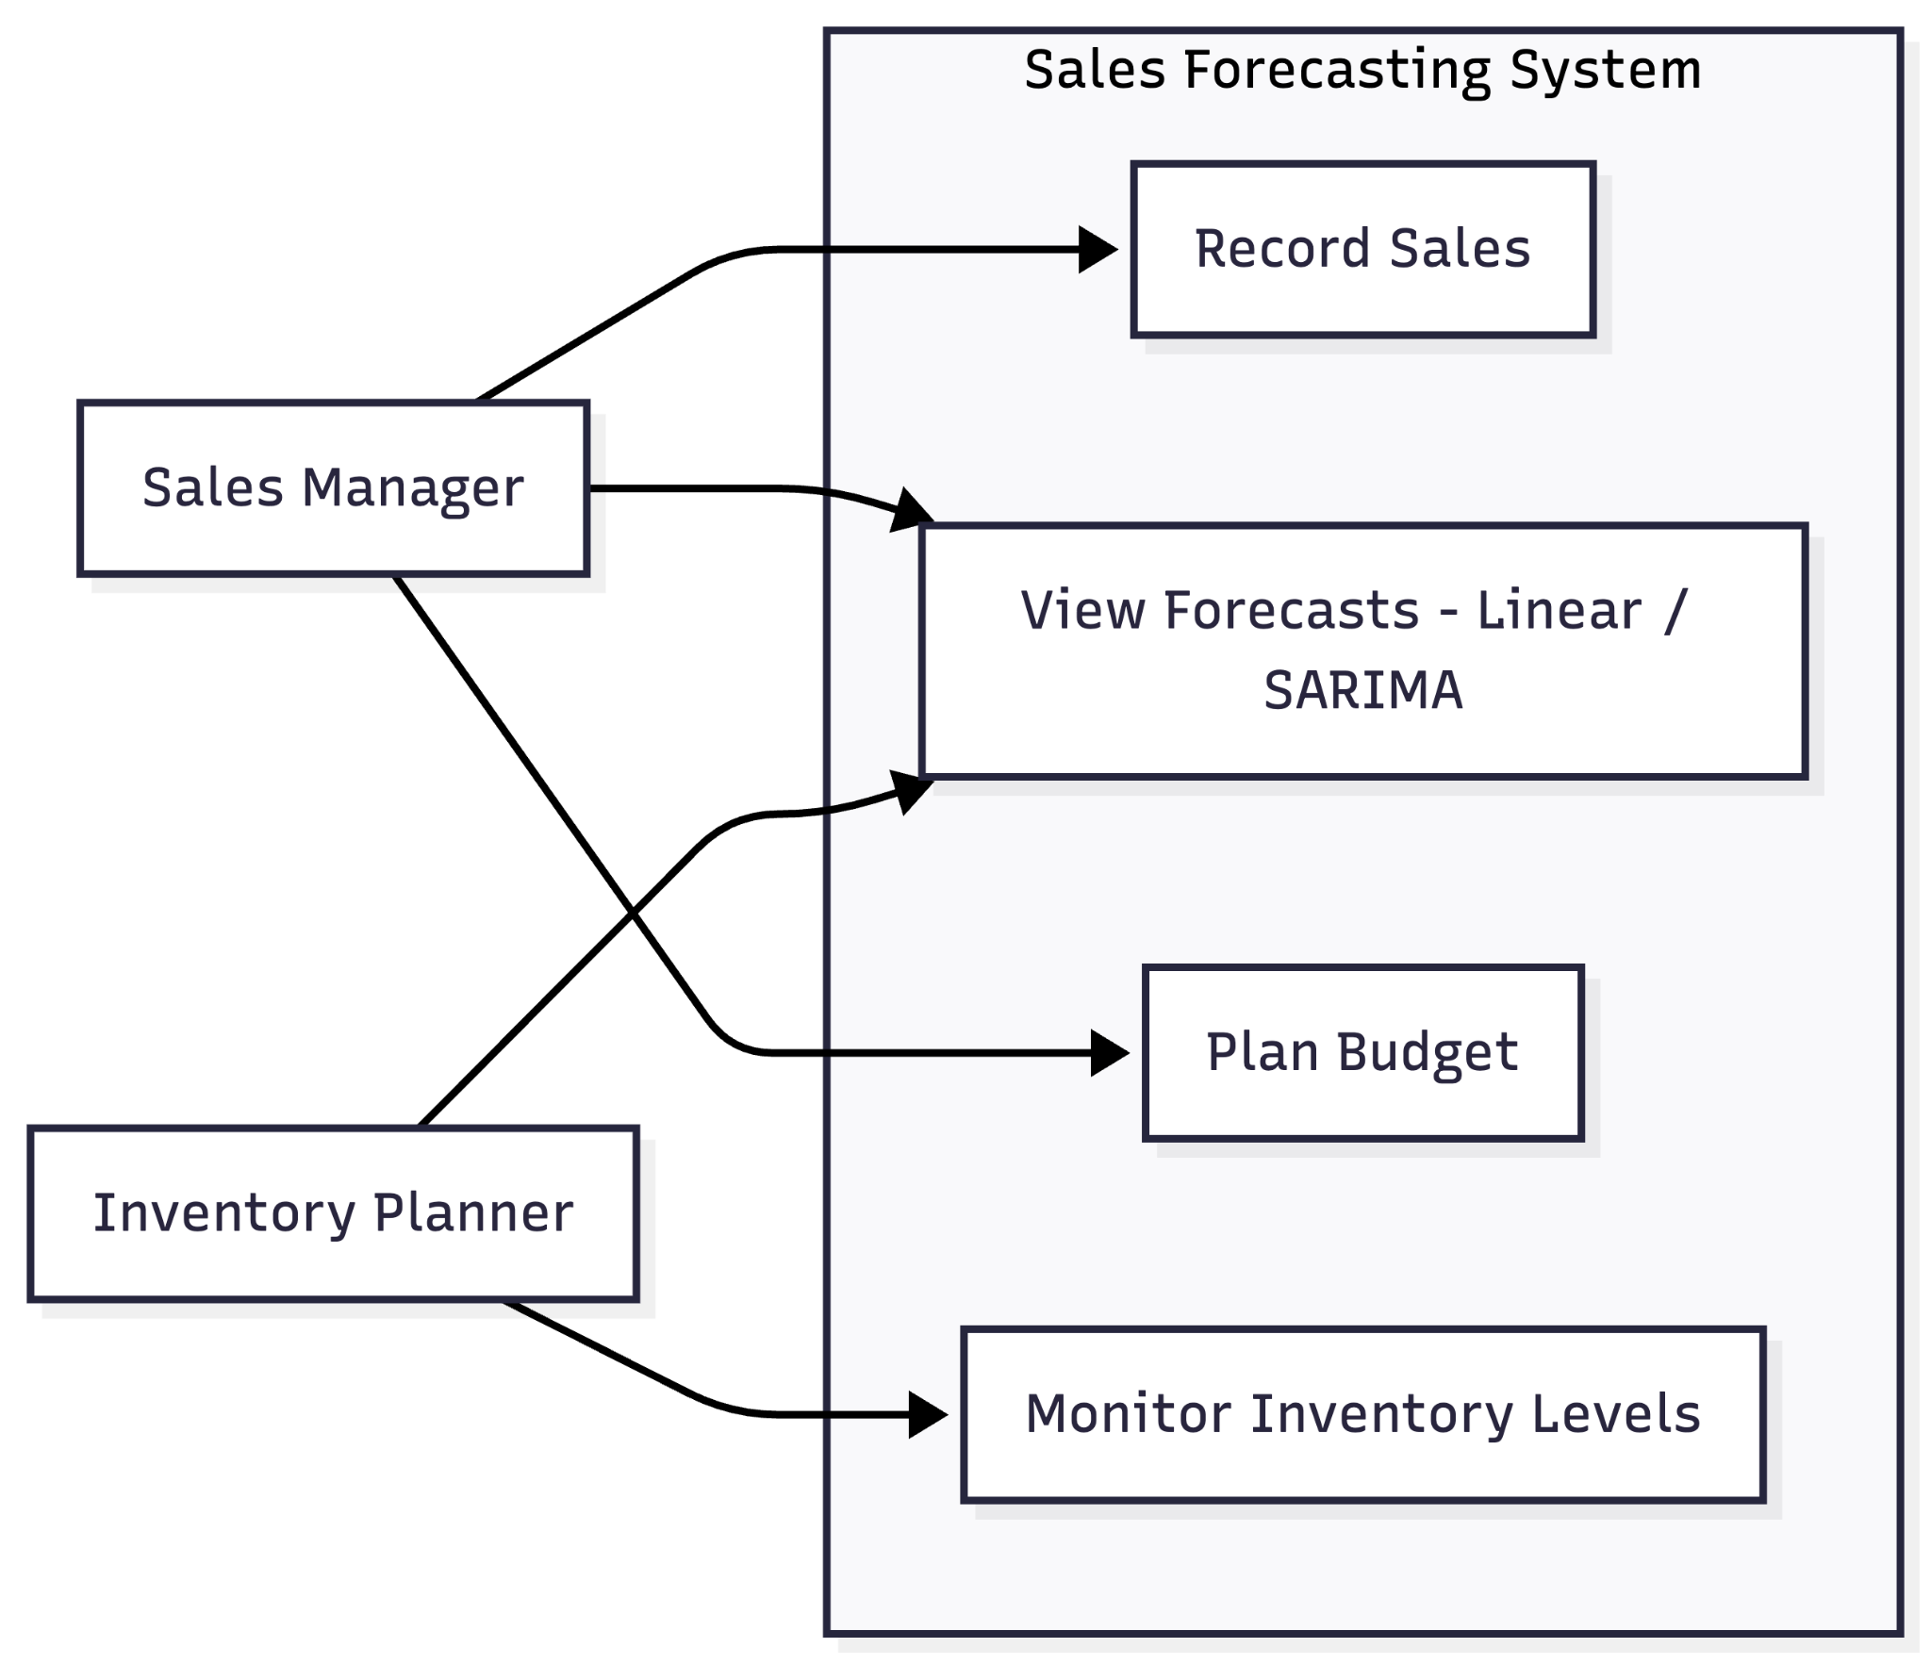
Figure 3.2: Use Case Diagram

3.5 Machine Learning Algorithms Used
Two key algorithms are implemented to handle different aspects of sales data behavior.

3.5.1 Linear Regression
A fundamental algorithm that models the relationship between time (date ordinal) and quantity sold.
• Justification: Excellent for identifying long-term growth trends and providing a stable baseline. It is extremely fast to compute and interpret.

3.5.2 SARIMA (Seasonal ARIMA)
A sophisticated time-series model that accounts for trend, noise, and seasonality.
• Justification: Essential for capturing cyclic patterns (e.g., higher sales every Friday or monthly spikes). It differences the data to handle non-stationarity, making it far more accurate for sales forecasting than standard regression.

3.6 Dataset Description
The system is designed to work with transactional sales data.
• Product Data: Name, Category, Cost Price, Selling Price, and current Stock Quantity.
• Sales History: Product ID, Quantity sold, Total amount, and precise Timestamp.
• Budget Info: Category-based allocation, Amount limits, and period durations.

3.7 Data Preprocessing and Model Training
• Resampling: Sales data is aggregated daily to ensure a continuous time series for the SARIMA model.
• Date Transformation: Dates are converted into numerical ordinals for the Linear Regression engine.
• Handling Nulls: Missing days in sales are filled with zero-sale placeholders to maintain frequency consistency.
• Model Switching: The system allows dynamic parameters (e.g., 7-day or 30-day horizons) to be passed via API.

3.8 Implementation Tools
• Backend: Python (FastAPI), SQLAlchemy (Database abstraction).
• Machine Learning: Scikit-learn (Linear Regression), Statsmodels (SARIMAX), Pandas (Data processing).
• Frontend: Next.js (React), Tailwind CSS (Styling), Recharts (Data Visualization).

CHAPTER FOUR: IMPLEMENTATION, RESULTS, AND DISCUSSION

4.1 Introduction
This chapter details the deployment of the forecasting engine and the resulting dashboard interface. We evaluate how the system handles inventory updates and compare the two forecasting models.

4.2 Experimental Setup
Tests were conducted using a synthetic dataset of 12 months of daily sales. The forecasting horizon was set to 7 days for real-time inventory planning.

4.3 Data Preparation
Sales data was ingested through the /sales/ endpoint, which automatically:
1. Decrements the stock_quantity in the Product table.
2. Updates the current_spend in the associated Budget record.
3. Logs the transaction for future model training.

4.4 Model Comparison Results
The system allows users to toggle between models to see varying results. Below is a visualization of the performance difference between the Linear Regression and SARIMA models.
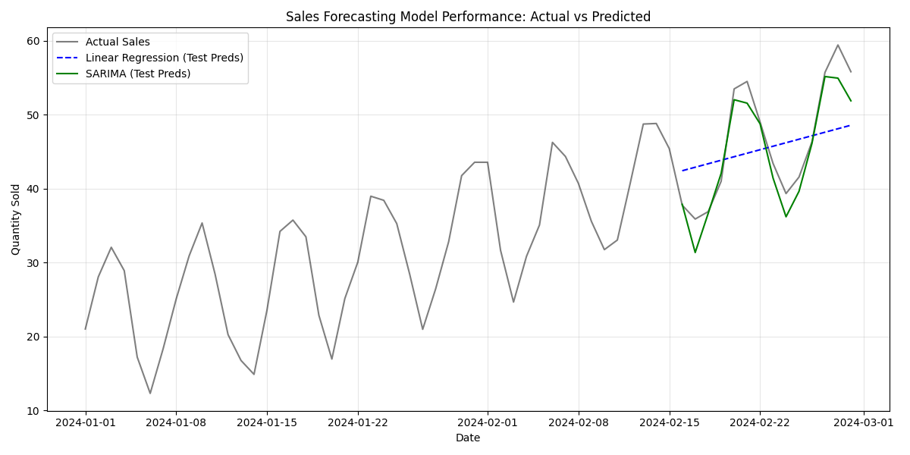

Figure 4.1: Model Comparison - Linear vs SARIMA
Table 4.1: Model Performance Comparison
Model | RMSE (Error) | MAE (Error) | Computation Time
Linear Regression | 6.76 | 6.10 | < 0.1s
SARIMA | 2.48 | 1.92 | ~0.8s
Note: Lower RMSE and MAE values indicate higher accuracy. SARIMA demonstrates superior precision by capturing seasonal fluctuations.
Table 4.2: Qualitative Model Comparison
Feature | Linear Regression | SARIMA
Trend Capture | High | High
Seasonality Capture | Low | High
Best Use Case | Stable long-term trends | High-frequency cyclic sales

4.5 Performance Analysis
During testing, the SARIMA model showed significantly lower error rates for products with clear weekly spikes. Linear Regression performed well for new products where seasonal data was sparse but tended to "oversmooth" during peak periods like weekends.

4.6 Inventory and Budget Integration
Success was measured by the system's ability to trigger budget warnings.
• Result: When sales exceeded the "Target" budget, the dashboard updated the "Budget Status" metric.
• Result: Predictive inventory replenishment suggestions were successfully generated based on SARIMA's 7-day quantity forecast.

4.7 Discussion
The integration of budget tracking into the sales flow is a key differentiator. By predicting future sales, the system allows managers to plan "Budget Allocation" for restocking before the stockout occurs, rather than reacting to an empty shelf.

4.8 Final Selection and Recommendation
The system is configured to offer SARIMA as the primary model for products with >30 days of history, while defaulting to Linear Regression for newer entries. This hybrid approach ensures reliability across all stages of a product's lifecycle.

